Bishop Carpenter Read, Write Inc
Set 1 Sounds

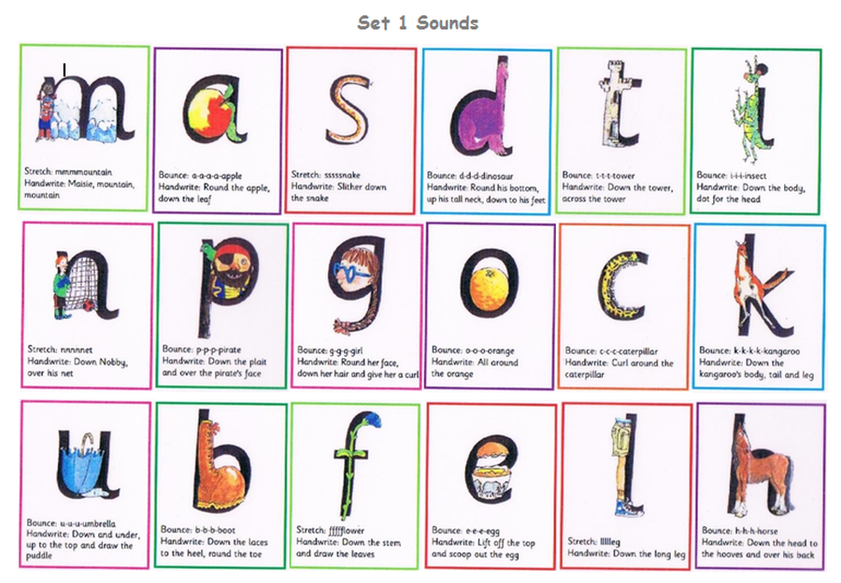
Stretch/Bounce = how we say the sound Handwrite = what we say as we write/form them

